**Project Design Phase-II**

**Data Flow Diagram & User Stories**

|  |  |
| --- | --- |
| Date | 01 november 2022 |
| Team ID | PNT2022TMID08233 |
| Project Name | AI BASED CLASSIFICATION OF SKIN DISEASE WITH ERYTHEMA |
| Maximum Marks | 4 Marks |

**Data Flow Diagrams:**

A Data Flow Diagram (DFD) is a traditional visual representation of the information flows within a system. A neat and clear DFD can depict the right amount of the system requirement graphically. It shows how data enters and leaves the system, what changes the information, and where data is store

**Example:** [**(Simplified)**](https://developer.ibm.com/patterns/visualize-unstructured-text/)

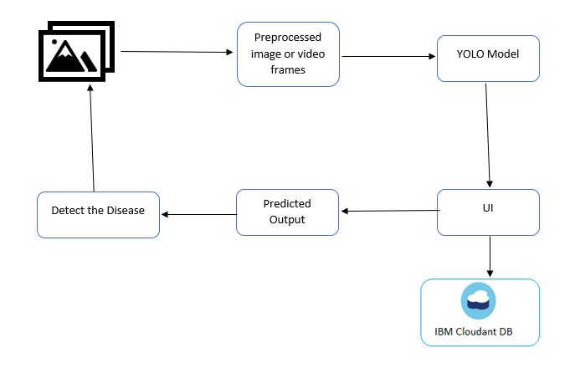

1. User login to the application
2. Upload the affected skin image
3. Image is processed by using yolo model
4. By using the dermdata in the IBM cloudant DB it predict the output
5. Detection of skin disease
6. Notification is displayed to the user

**DATA FLOW DIAGRAM FOR DETECTION OF SKIN DISEASE**

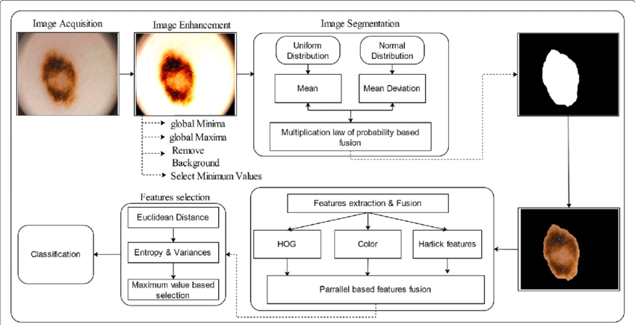

**User Stories**

Use the below template to list all the user stories for the product.

| **User Type** | **Functional Requirement (Epic)** | **User Story Number** | **User Story / Task** | **Acceptance criteria** | **Priority** | **Release** |
| --- | --- | --- | --- | --- | --- | --- |
| Customer (Mobile user) | Registration | USN-1 | As a user, I can register for the application by entering my email, password, and confirming my password. | I can access my account / dashboard | High | Sprint-1 |
|  |  | USN-2 | As a user, I will receive confirmation email once I have registered for the application | I can receive confirmation email & click confirm | High | Sprint-1 |
|  |  | USN-3 | As a user, I can register for the application through Facebook | I can register & access the dashboard with Facebook Login | Low | Sprint-2 |
|  |  | USN-4 | As a user, I can register for the application through Gmail | I can submit the application form | Medium | Sprint-1 |
|  | Login | USN-5 | As a user, I can log into the application by entering email & password | I can able to login by clicking login | High | Sprint-1 |
|  | Dashboard | USN-6 | As a user , I can see many options given in the dashboard | I can go to any option by clicking those option | High | Sprint-1 |
| Customer (Web user) | Registration | USN-7 | As a user, I can register for the application by entering my email, password, and confirming my password. | I can access my account / dashboard | High | Sprint-1 |
|  |  | USN-8 | As a user, I will receive confirmation email once I have registered for the application | I can receive confirmation email & click confirm | High | Sprint-1 |
|  |  | USN-9 | As a user, I can register for the application through Facebook | I can register & access the dashboard with Facebook Login | Low | Sprint-2 |
|  |  | USN-10 | As a user, I can register for the application through Gmail | I can submit the application form | Medium | Sprint-1 |
|  | Login | USN-11 | As a user, I can log into the application by entering email & password | I can able to login by clicking login | High | Sprint-1 |
|  | Dashboard | USN-12 | As a user , I can see many options given in the dashboard | I can go to any option by clicking those option | High | Sprint-1 |
| Customer Care Executive | Call | USN-13 | As a user , I can call to customer care , if I have any doubts | I can call to the customer care number | Medium | Sprint-2 |
| Administrator | Admin | USN-14 | As a user , I cannot have a access to some of the functions | Those options and functions cannot be accessed | Low | Sprint-2 |